Get the e-learning 2015 symposium app!

This year, the e-learning symposium is going mobile again! Like last year, we are using a conference app, Guidebook, which will give you access to the full programme and abstracts, build your own schedule and create your to-do list.

>> FOR IPHONES, IPADS, IPOD TOUCHES AND ANDROID DEVICES <<
1

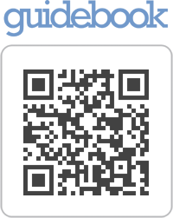
To get the Guidebook app choose one of the methods below:

- Download 'Guidebook' from the Apple App Store or the Android Marketplace
- OR visit http://guidebook.com/getit from your phone's browser
- OR scan the following image with your mobile phone (QR-Code reader required, e.g. 'Red Laser', 'Barcode Scanner' – these apps are also apps you can download)

2

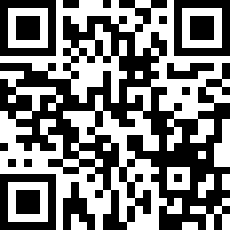
To find the e-learning symposium guide, click on "Download Guides" at the bottom of the screen and either:

- Enter ‘e-learning symposium 2015’ in the search box
- OR enter the redemption code elearnllas15
- OR scan the QR code below:

>> FOR WINDOWS PHONE 7 AND BLACKBERRY DEVICES <<
1

To access Guidebook, go to the Guidebook mobile site http://m.guidebook.com and either:

- Search for ‘e-learning symposium 2015’ in the search box
- OR enter the redemption code elearnllas15
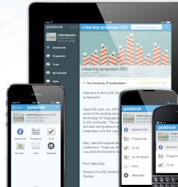
Please note: Windows 7 and Blackberry users can access the same information apart from ‘my schedule’.

Here is a screen shot of what your e-learning symposium 2015 guide should look like – if it doesn’t, you’re probably looking at the wrong event!

>> ONLINE ACCESS <<
1

To access Guidebook online, go to http://guidebook.com/guide/30212 and enter the redeem code elearnllas15

